AI-powered Chatbot Extracts Information and Answers Questions about NVIDIA CUDA SDK & other websites
This document outlines a Python application that utilizes artificial intelligence to extract information from websites and answer user queries based on that information.

Core Functionalities:

- Website Exploration: The application leverages Beautiful Soup, a Python library, to parse the HTML structure of a website and extract relevant content.

- Understanding Through Langchain: Langchain, a powerful NLP (Natural Language Processing) library, plays a crucial role in enabling the application to comprehend the extracted website content. Langchain facilitates the creation of applications that can interact with and understand natural language.

- Conversational Retrieval Chains: This application employs Langchain's Conversational Retrieval Chains to tailor responses to the user's specific questions and conversation history. By considering both the website content and the conversation flow, the application generates contextually relevant answers.

- User Interface with Streamlit: Streamlit, a user-friendly Python library, streamlines the development of the application's front-end. This allows users to interact with the application through a clear and intuitive interface.

Libraries: Several key Python libraries contribute to the application's functionality

- Beautiful Soup (Web Scraping): Parses the HTML structure of a website, allowing the application to extract relevant text and information.
- Langchain (Natural Language Processing): Plays a crucial role in enabling the application to understand the extracted website content and user queries. Langchain facilitates the creation of applications that can interact with and understand natural language.
- Langchain OpenAI (Optional): Integrates with OpenAI's powerful language models for potentially more advanced chatbot capabilities (not covered in this example).
- python-dotenv (Environment Variables): Securely manages environment variables used by the application.
- Streamlit (Front-End Development): Streamlines the development of the user interface, creating a clear and intuitive experience for users to interact with the application.
- Chroma (Vector Store): (Optional, but recommended) Stores the extracted website text as mathematical vectors. These vectors capture the semantic meaning of the text,

allowing for efficient comparison and retrieval of relevant information.

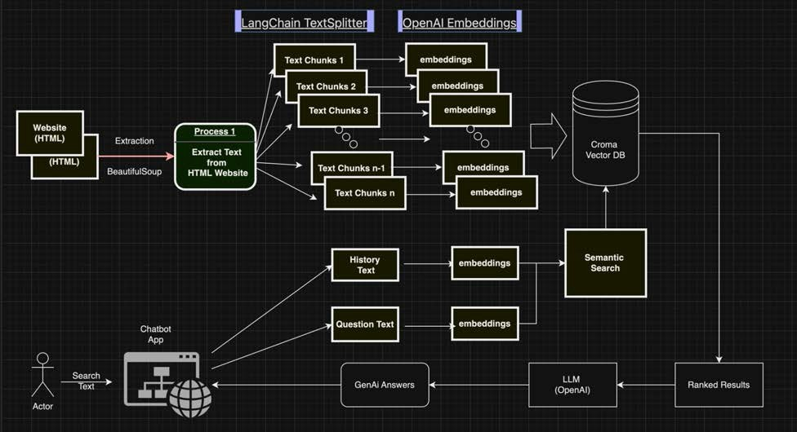

How it Works:

- User Input: Users provide the URL of a website they want to explore through the Streamlit interface.

- Website Exploration: The application utilizes Beautiful Soup to parse the website's HTML, extracting relevant text and information.

- Understanding and Retrieval: Langchain steps in to analyze the extracted information. Here, the application employs a vector store like Chroma to represent the extracted text as mathematical vectors. These vectors capture the semantic meaning of the text, allowing for efficient comparison and retrieval. Langchain then uses these vectors to identify the most pertinent sections that align with the user's potential queries.

- Conversational Response: When a user enters a question, the application utilizes Langchain's Conversational Retrieval Chains. These chains consider both the user's query (also converted into a vector) and the relevant website content vectors to generate an informative and contextually appropriate response.

- Response Generation: Based on the retrieved website content, the application doesn't necessarily create entirely new content. Instead, it utilizes the retrieved information to formulate a response that addresses the user's question directly. This response may involve summarizing relevant sections of the website, providing paraphrased
explanations, or highlighting key points directly from the source material.

- Refinement and Improvement: The application undergoes continuous testing with various websites and user queries. This testing helps identify and address any bugs, ultimately enhancing the application's accuracy and effectiveness.

Beyond NVIDIA:

While the writeup uses the NVIDIA CUDA SDK website as an example, the application technology can be used to explore and answer user questions about many websites, making information retrieval and exploration more efficient and user-friendly.

